EAA 292 2018 Fly-in Final Report
Sept 15 2018
David Ullman: chair with lots of input from others.

Contents
Statistics (thanks to Deb Kelley) 2
Dinner Stats 2
Breakfast stats 2
Committee Organization 3
Schedule 4
People 6
Budget and Profit sheet 8
ROBB Reports 9
Fly-in chair ROBB Report 9
Ramp Boss Road Map 12
Web Site ROBB Report 13
Breakfast ROBB Report 15
Lunch and Dinner ROBB Report 16
Budget and Finance ROBB Report 18
Registration ROBB Report 19
Silent Auction ROBB Report 21
STOL ROBB report 23
How to Run a Silent Auction 24
General comments 28
STOL comments from Jerry Pryce 28
Eric Pretorious comments 28
Marcia Noell comments 29
Dottie and Richard Moriarity suggestions 29
Vince Homer feedback 31
Deb Kelly feedback 33
Mike Ryer notes 36

Statistics (thanks to Deb Kelley)

Dinner Stats
Friday Dinners:
75 Dinners Ordered X $6 = $450
13 Extra Dinners X $16 = $208
FRI Profit = $658

Saturday Dinners:
100 Dinners Paid X $6 Profit = $600
21 Dinners X $22 = $462 Profit

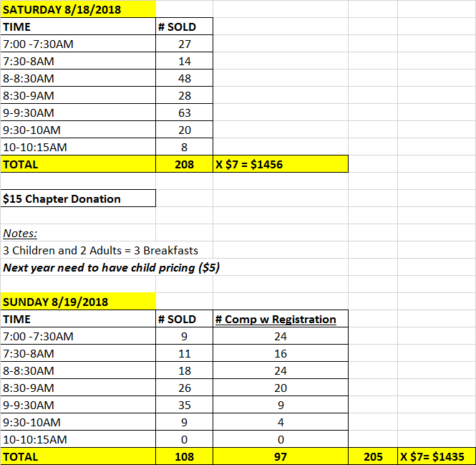
Breakfast stats

Committee Organization

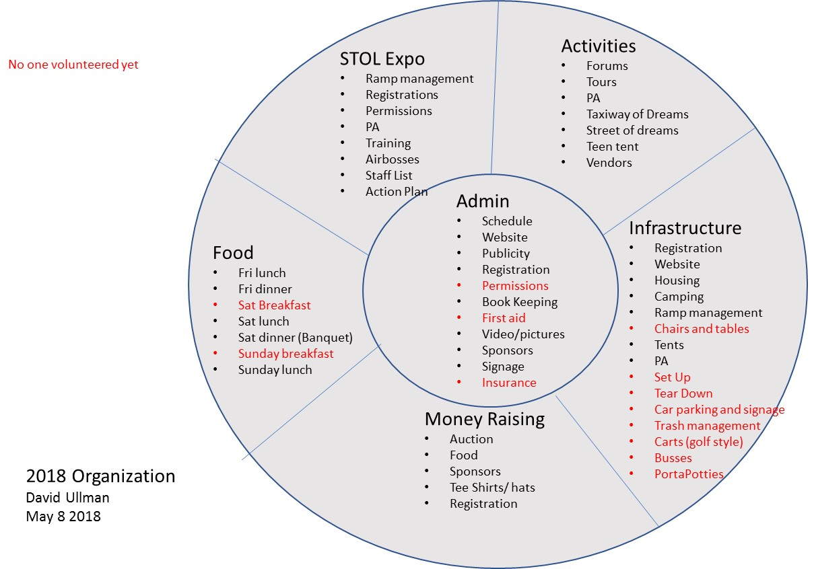

Schedule
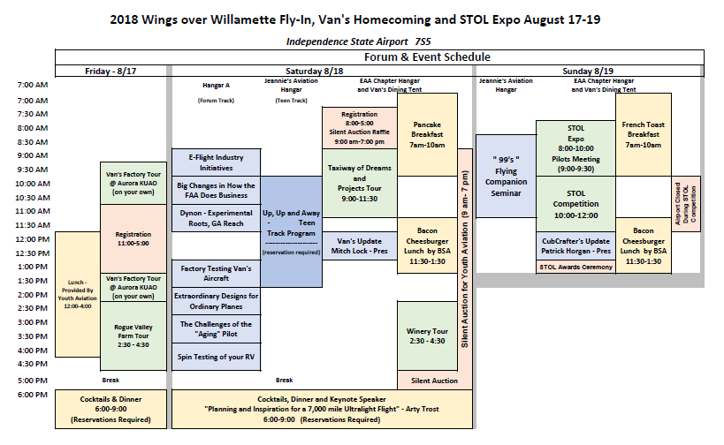
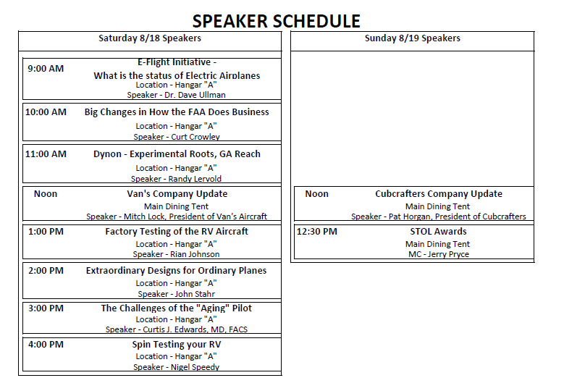

People

Infrastructure
 | Housing | Judy Yerian
 | Camping | Donna Bartle
 | Ramp management | Vince Homer
 | Chairs and tables
 | Tents | David Ullman - Vans
 | PA | Mike Ryer
 | Set Up
 | Tear Down
 | Car parking and signage
 | Trash management | Yerians
 | Carts (golf style)
 | Busses
 | PortaPotties | Ullman
Admin
 | Schedule | Mike Kelley
 | Website | John Coyier
 | Publicity | David Ullman
 | Registration | Dottie Moriarity (Rich)
 | Permissions | David Ullman
 | Book Keeping | Bill McLagan
 | First aid
 | Video/pictures | Ron Singh, Sam Butler
 | Sponsors | David Ullman
 | Signage | David Ullman
 | Insurance | David Ullman
Activities
 | Forums | Mike Kelley
 | Tours | Deb Kelley??
 | PA | Mike Ryer
 | Taxiway of Dreams | Bruce Patton
 | Street of dreams | ????
 | Teen tent | Mike Ryer
 | Vendors | David Ullman ???
Money Raising
 | Auction | Marcia Noell
 | Sponsors | See above
 | Tee shirts | Rod Kerr
 | Registration | Bill McLagan
Food
 | Fri lunch | Deb Origer
 | Fri dinner | Deb Kelley
 | Sat Breakfast | Mike Short
 | Sat lunch | Boy Scouts
 | Sat dinner (Banquet) | Deb Kelley
 | Sunday breakfast | Mike Short
 | Sunday lunch | Boy Scouts
STOL
 | Ramp management | Jerry Pryce
 | Registrations
 | Permissions
 | PA
 | Training
 | Airbosses
 | Staff List
 | Action Plan

Budget and Profit sheet

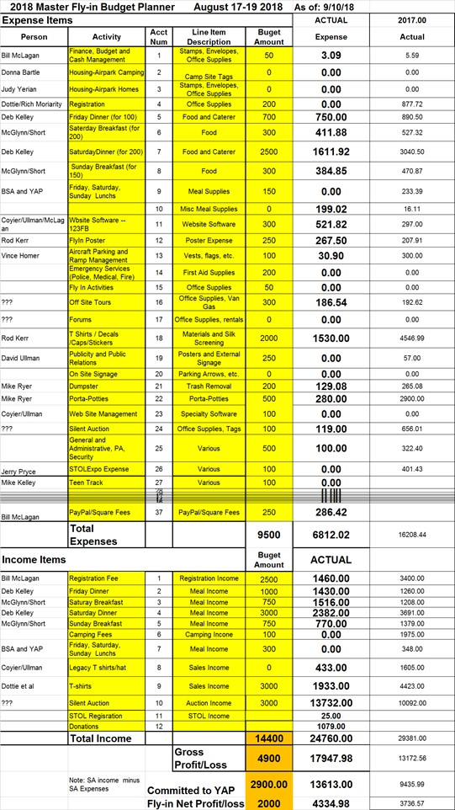

ROBB Reports
ROBB stands for “Run Over By a Bus”. If you were ROBBed would anyone else know how to fill your role? Actually, this exercise serves two other purposes: 1) It gets you off the hook for doing it next year. You can hand off the how-to-do-it sheet (your ROBB report) to the next person. 2) It is easily editable so that you or your successor can change it with lessons learned.

Fly-in chair ROBB Report

Role: |  | Fly-in Lead | Last Updated by: |  | David Ullman |  |  | Date: | 8/24/18
 | Task |  |  | Due Date |  | Coordinate with | Notes
1 | Check with AOPA about their fly-in dates and ID other local conflicts |  |  | Dec 30 |  | <Chris.Eads@aopa.org> | This often takes repeated pings to AOPA. Start in October
2 | Schedule meeting with leads |  |  | Dec ?? |  | All leads | See who wants to re-up. Check at December membership meeting
3 | Set Fly-in Date |  |  | Jan 31 |  | All leads at meeting
4 | Hustle to get Leads for all committees as needed |  |  | Jan |  |  | Secure commitments from all. This often drifts on.
5 | Work with Artist on poster/logo |  |  | Jan |  | Artist
6 | Set up monthly meeting date |  |  |  |  | All leads
7 | Get poster out to EAA Chapters in NW and other Orgs |  |  | Mar 1 |  | Brian McGlynn
8 | Ensure sponsors in place |  |  | Mar 15 |  | Vans  CubCrafters  LightSpeed
9 | Ensure Vans is ordering the tent |  |  | Mar 15 |  | AA tents 40 x 60
10 | Order toilets |  |  | April 15 |  | Royal Flush (Tony) - 1 ADA, 1 reg | 831-1361 cell 971-600-0122
11 | Order disposals |  |  | April 15 |  | Brandts - 2 dumpsters | Brandts- (503) 838-0464
12 | Check with IceCream and other food vendors |  |  | April 15 |  | Beals Ice cream. Maybe add other vendor carts for food | Beals 503-837-9002  Consider adding Speak Cheezy next year 503-420-2472
13 | Finalize Registration form and make sure it is posted |  |  | March 30 |  | Web guru and  Breakfast, Dinner, Registration, Housing Leads
14 | Check with Marquis spa about parking |  |  | April 30 |  | Parking manager | Roger Rosenau  rrosenau@marquiscorp.com 503-838-0888
15
16 | Start bi-weekly meetings |  |  | July 1
17 | Review existing signage with leads |  |  | July1 |  |  | Find out what is needed
18 | Make signs |  |  | July |  |  | If EAA 292 cant print them in house contact Copy-Cats in west Salem
19
20 | Check with vendors to ensure all is in place and set times for delivery on Thursday before event |  |  | 2 weeks prior |  | Royal Flush  Brandts  AATents
21
22 | Put up signs
23 | Be at EAA on Thursday before event to coordinate tent, toilets, dumpsters etc. |  |  | 1 day prior
24 | Update this report |  |  | Late August
25

Ramp Boss Road Map

Role: |  | Ramp Boss | Last Updated by: |  | V. Homer |  |  | Date: | 9/18
 | Task |  |  | Due Date |  | Coordinate with | Notes
1 | Commit to position |  |  | 1/19 |  | Fly-In Lead
2 | Attend kick-off meeting |  |  | 1/19
3 | Solicit Ramp Rat volunteers |  |  | 5 & 6/19 |  | EAA Activities Lead | Pass-around at EAA meetings (2) and airpark Block Herold.
4 | Meet with volunteers |  |  | 5 & ^/16 |  |  | During EAA meetings
5 | Obtain ramp space assignments |  |  | 5-7/19 |  | Fly-In Committee
6 | Coordinate with STOL |  |  | 5-7/19 |  | STOL Lead | Parking and contest traffic
7 | Develop Ramp Rat handout |  |  | 6-7/19 |  | Fly-In committee
8 | Update aerial map |  |  | AR |  | Fly-In committee
9 | Formalize ramp rules |  |  | 7/19 |  | Fly-in committee | This has not been done in recent history. Needed?
10 | Identify signage |  |  | 7/19 |  | STOL Lead | Fly-In committee buy-in
11 | Submit signage copy |  |  | 7/19 |  | Sign Guru
12 | Assemble signs |  |  | 8/19
13 | Organize supplies |  |  | 6 +8/19 |  |  | Prop cards, vests, paddles, radios, bikes, mopeds, stanchions, cones, hazard tape, rope, etc.
14 | Arrange for ramp resident AC to be moved |  |  | 8/19 |  | Robin Reed
15 | Schedule emergency services |  |  | 7/19 |  | Fire Dept.
16 | Internal emergency supplies |  |  | 8/19 |  | Airport CERT
17 | Make up and distribute Ramp Rat work schedule |  |  | 8/19
18 | Install signage |  |  | Fly-in week
19 | Script and conduct AM Safety briefing for Ramp Rats |  |  | Fly-in week |  | Ramp Rats

Web Site ROBB Report

Role: |  | Web site | Last Updated by: |  | John Coyier |  |  | Date: | 9/6/18
 | Task |  |  | Due Date |  | Coordinate with | Notes
1

Date: the web page for the year’s annual fly in should be up and running by April 20. I just pulled this date out of thin air. It’s really not that urgent as almost no one, unless asked to do so, will register for this event more than even a month out which would be June/July. One should be reasonably well versed with both the web site app to be used and the forms app by the end of Feb. This will allow the month of March to begin getting the thing in final shape with all the input you need to do it. By April registration trials should be ready to run.

Task: Create the web page(s) pertinant to the Fly In which include
- home page poster image with links to registration form
- main registration form with payment function
- STOL registration form
- activities schedule page(s)
- STOL pilot page

Coordination contacts:
- Fly In lead
- Registration lead
- Housing & camping lead
- STOL lead
- Forums lead

Things you need to create the Fly In pages:
- main Fly In poster
- STOL page image/poster
- listing of required data set needed from applicants (clients).
- Banking info – to set up payment system

Notes:

WIX was the main web authoring application we used for 2018.
123Formbuilder was used for 2018. To get “rules” functionality we had to go with the Premium paid plan then turned it off after the FlyIn was over ($45/mo?).

It really helps to set up your own WIX and 123Formbuilder personal accounts to practice on prior to start in on the main chapter’s accounts. It’s amazing how you can screw things up without even knowing it.

The PayPal app available within WIX was used. It provides the option to pay direct using a credit card with no need to have the client set up an account.

Use of “rules” on the 123Formbuilder form was a bit challenging but I eventually got it to do what I was expecting it should. This mainly had to do with getting the app to display the correct amount as the client made the various choices on the form. Several trials were done prior to release to make sure the form and payment functioned as required.

It took some learning to figure out how to scale images and get them to display nicely on the web site. The main thing was starting with a file with enough resolution to work with. You may need to go back to the supplier (whoever gave you the file) and get a workable file size.

Need discount for code on website for speakers.

There were last minute additions like Silent Auction item images/descriptions, a Teen event on Saturday and probably some others I am not recalling.

Breakfast ROBB Report

Role: |  | Breakfast lead | Last Updated by: |  | Mike Short |  |  | Date: | 9/18/18
 | Task |  |  | Due Date |  | Coordinate with | Notes
1 | Prepare signage  Contact volunteers at EAA Chapter meeting and by blast email |  |  | One month before |  | Signmaker
2 | Set up kitchen panels, grills, get propane  Order bread from Franz |  |  | One week before |  | Lyn McDonald for panels
3 | Buy groceries |  |  | Wednesday before |  |  | Costco, Smart food service warehouse, Franz outlet
4 | Clean kitchen |  |  | Thursday before
5 | Clean utensils and set up coffee pots |  |  | Friday night before
6 | Start sausage and set up condiment table start coffee pots |  |  | 5 AM day of fly in
7
8
9
10
11
12

Lunch and Dinner ROBB Report

Role: |  | Lunch & Dinner/ Cash Bar Lead | Last Updated by: |  | Deb Kelley |  | Date: | 9/3/2018
 | Task |  |  | Due Date |  | Coordinate with | Notes
1 | Confirm Fly-In Dates with Boy Scout Lead for Lunch on Friday and Saturday night. |  |  | As soon as Fly In Date is confirmed. |  | Boy Scout Lead:  Steve Mosier-BSA  Cell: 503-930-8365  Home: 503-838-2240  mosermob@gmail.com | As soon as you know dates of Fly-In contact BSA Lead and ask if they will do Lunch on Saturday and Lunch on Sunday. They charge $7 for Bacon Cheeseburger, Chips and Drink on both days. In 2018 they sold 200 on Saturday and 200 on Sunday.
2 | Confirm Fly-In Dates with Caterer for Dinner on Friday and Saturday night. |  |  | As soon as Fly In Date is confirmed. |  | Caterer: Jerry Crane: That Food Guy-5434 River Road North #144; Keizer, OR 97303. 503-910-4695. www.thatfoodguycatering.com | Ask for a $10 Dinner for Friday Night and charge $16. In 2018 we ordered 75 dinners and sold 88. Ask for a $15 Dinner for Saturday night and charge $22. Saturday Dinner has a key note speaker so is typically a bit nicer. In 2018 we reserved 100 dinners and sold 122, We only comp one dinner for the Key Note Speaker. Caterer will make 10% more than the number you order which gives you room to add more dinners for better profit. He requires a 50% Deposit based on number ordered and final count 5 days before event.
3 | Confirm Fly-In Dates with Caterer for Cash Bar on Friday and Saturday night. |  |  | As soon as Fly In Date is confirmed. |  | Caterer: Jerry Crane: That Food Guy-5434 River Road North #144; Keizer, OR 97303. 503-910-4695. www.thatfoodguycatering.com | Caterer has liability Insurance to cover the event. Friday night less alcohol is purchased but Saturday night more is purchased.
4

Budget and Finance ROBB Report

Role: |  | Budget/Finance | Last Updated by: |  | Bill McLagan |  |  | Date: | 9/6/18
 | Task |  |  | Due Date |  | Coordinate with | Notes
1 | Create preliminary budget |  |  | Dec 30 |  | Fly-in Lead | Use prior year as a guide/template.
2 | Arrange payment of web site fees |  |  | Feb |  | Web Site lead | Monthly payments until after fly-in.
3 | Update budget |  |  | Jan - Sept |  | Fly-in Lead | Present at each meeting
4 | Enter payments/expenses into budget |  |  | Jan - Sept |  | Fly-in Lead | Log paypal receipts by name in budget (validation for refunds if necessary)
5 | Pay Fly-in expenses |  |  | Jan - Sept |  | Fly-in Lead | Note expenses in budget
6 | Arrange for Cash boxes and starting cash |  |  | August |  | Registartion,  Food, Silent Auction | Count cash and reset starting cash after each event.
7 | Count cash/checks and arrange deposit in bank |  |  | August |  | Chapter Treasurer | Large amounts of cash triggers $5 handling fee
8 | Pay out refunds |  |  | September |  | Registration lead | As requested/required
9 | Pay final bills |  |  | September |  | Fly-in Lead
10 | Prepare final budget results and coordinate with chapter treasurer |  |  | September |  | Treasurer,  Fly-in Lead | Budget income/expenses should match chapter treasurer’s records
11
12
13
14
15
16
17

Registration ROBB Report

Role: |  | Registration | Last Updated by: Dottie Moriarity |  |  |  |  | Date: | 8/26/18
 | Task |  |  | Due Date |  | Coordinate with | Notes
1 | Inventory Supplies on Hand |  |  | Mar 1 |  | EAA | Left Over supplies should be stored at Hangar
2 | Order any new supplies |  |  | Mar 10 |  | Previous Chair | Lanyards ordered by email from China
3 | Coordinate with Web designer on on-line registration form |  |  | Mar 30 |  | Web designer | It is vital that the online reports be pertinent to information required by Registration and other chairs.
4 | Print out any new reports on a daily basis |  |  | Daily after form goes online |  | Other chairs as needed | If there is an Excel spreadsheet generated, download and create a spreadsheet specific to your needs and update daily
5 | Decide on name tag process and how to indicate dinner reservations and make them up as registrations come in |  |  | Daily after form goes online |  | Event Chair | Speakers and noted guests should be on special tags and lanyards
6 | Generate a request to volunteers for manning the Registration Desk |  |  | May 5 |  |  | Announce at Chapter Meetings and call on past volunteers
7 | Set up Work Schedule and provide copy to volunteers |  |  | July 15
8 | Procure from other chairs all data that is to go into the Registration Packets and get copies made |  |  | July 30
9 | Stuff Packets |  |  | August 5
10 | Confirm how walk up registrations will receive name tag lanyards |  |  | August 5
11 | Set up Registration Area |  |  | Thursday before Fly-In |  | Set Up Crew
12 | Get set up for Square credit card payments |  |  | Thursday before Fly-In |  | EAA Treasurer
13 | Train Helpers |  |  | Friday AM  Prior to 9:00 AM
14 | Keep lists updated for walk up dinner requests  If there are dinners available to sell |  |  | Daily for Friday and Saturday |  | Food Chair
15 | Close desk at 5 pm and turn over cash box to Treasurer |  |  | Daily for Friday and Saturday
16 | Have fun and enjoy yourself.

Silent Auction ROBB Report

Role: |  | Silent Auction | Last Updated by: |  | Marcia Noell |  |  | Date: | 9/15/2018
 | Task |  |  | Due Date |  | Coordinate with | Notes
1 | Attend Fly-In meetings |  |  | Monthly |  | Fly-In chair
2 | Request donations airpark crafts |  |  | Monthly |  | Block Heralds
3 | Request EAA 292 donations-email, meetings & Newsletter |  |  | Monthly |  | EAA editor & meeting chair
4 | Recruit auction committee volunteers |  |  | January
5 | Define auction subcommittees and assign lead volunteers |  |  | January
6 | Recruit subcommittee volunteers |  |  | January
7 | Chair auction meetings |  |  | Monthly |  | Subcommittee leads
8 | Manage donations |  |  | ongoing
9 | Define schedule for closing auction |  |  | May |  | Fly-in Committee
10 | Coordinate ALL tasks outside of auction that occur during fly-in  - PA announcements  - Raffles  - Auction close announcements  - Live auctions  - Double down donations |  |  | May-Aug |  | Fly-in Committee
11 | Advertise auction on fly-in registration pages |  |  | June |  | Webmaster
12 | Submit signage needs |  |  | July |  | Dave Ullman
13 | Test run of auction procedures
14 | Set-up
15 | Start auction
16 | Clean up |  |  | Day after auction
17 | Deliver unclaimed items |  |  | ASAP
18 | Write tax letters to donors |  |  | After auction
19 | Write thank you notes to donors |  |  | After auction
20 | Write thank you notes to volunteers |  |  | After auction
21
22
23
24
25

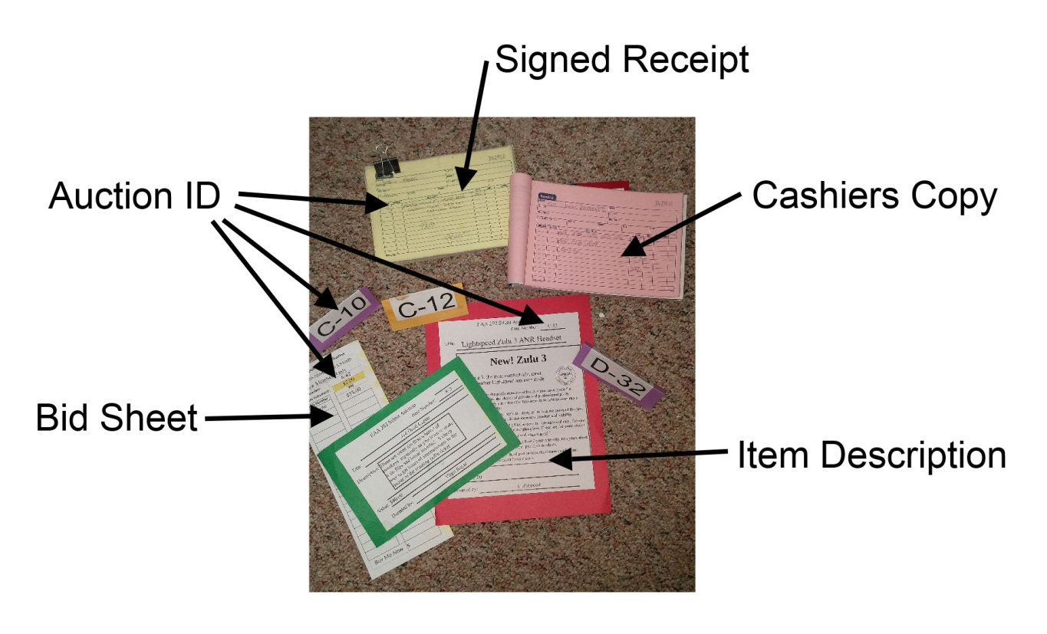

Forums ROBB Report

STOL ROBB report

Role: |  | STOL BOSS | Last Updated by: |  | Jerry Pryce |  |  | Date: | 10/2/18
 | Task |  |  | Due Date |  | Coordinate with | Notes
1 | Organizational meeting to set-up discuss Action Plan/STOL Event Date |  |  | Nov prior |  | Past STOL volunteers
2 | Review/edit Action Plan |  |  | Jan 31 |  | STOL Advisors | Review existing plan for errors/needed changes
3 | Review/edit STOL pilot rules & information sheets |  |  | Jan 31 |  | STOL Advisors
4 | Designate STOL team positions |  |  | Jan 31 |  | STOL Advisors
5 | Recruit volunteers |  |  | Feb 28 |  | EAA 292 President | Call on past volunteer corps/recruit at mo. mtgs
6 | Solicit Sponsors |  |  | NLT Jun
7 | Contact last year’s contestants |  |  | Jan 31 |  | STOL Advisors | Designate someone to contact pilots via phone & email
8 | Coordinate approval of Action Plan with ODA |  |  | 2 mo < |  | Matt Maass
9 | Coordinate approval of Action Plan with FAA |  |  | 2 mo <
10 | STOL Team Practices |  |  | 1 mo < |  | Jim Oveross/Dave Smith | 3-4 practices spaced out over the month to 1 wk <
11 | Notify Airport businesses of airport closure for STOL contest |  |  | 1mo < event |  |  | Starduster Café; Nutsch Aviation
12 | Coordinate Airport closure NOTAM with ODA |  |  | 2weeks < event |  | Matt Maass
13 | Calendar item to Newspaper |  |  | 1 mo< &  1 week <
14 | STOL article/calendar item to Backcountrypilot.org |  |  | 6mo < &  1 mo <
15 | Coordinate publicity on local pilot boards |  |  | Jan – 1 wk <
16 | Register pilots |  |  | 1 day < |  | STOL Boss | Start 6 mo< and close 1 day<
17 | Confirm contestants |  |  | 1 day<
18 | Prepare AC Sequence sheet(s) |  |  | 1 day< |  | Air Boss
19 | Contest Safety Briefing |  |  | 1 hour< |  | STOL Boss & Air Boss
19 | Scoring |  |  | Contest end |  |  | Need at least two people
20 | Awards |  |  | I hr after contest |  |  | Need at least two people
21
22
23
24
25

How to Run a Silent Auction

Silent auctions are auctions held without an auctioneer. People place their bids on sheets of paper instead. They're often used by charities to raise money, but they can be tricky to put together. With good planning, however, it's easy to set up an auction and get the most out of your items. Soon enough, you'll have raised a good amount of money in just a few hours!

Preparing for the Auction

Work with Fly-In Committee throughout process
- Attend Fly-In committee meetings to raise issues pertinent to the auction and keep event organizers informed
- Coordinate ALL auction activities that impact other fly-in events
- Work with Fly-In committee to figure out when auction sections will close
- Work with Fly-In committee regarding announcements
- Reminders of section closing times
- Announcing raffle winners
- Conducting live auction if auction committee plans to hold any items for live auction

Recruit volunteers.

- Determine subcommittees – The following areas may benefit if they each work as a subcommittee with its own chair person
- Volunteers to help set up
- Volunteers to monitor and close tables at the appointed time and make sure minimum bid and minimum increment requirements were met. These people will need to know the rules of the silent auction and who to go to for questions they can’t answer
- Cashiers to organize winning bids (especially of multiple winners) and collect money from winning bidders
- Clean-up crew
- Volunteers to solicit donations – remind donors they will get tax documents for their donation and who benefits from the auction
  - Prepare a short letter for prospective donors stating purpose of auction proceeds and availability of tax letters
  - Ask local businesses - restaurants, salons, golf course, Lightspeed, Dynon etc.
  - Send emails to Airpark community
  - Ask for donations at chapter meetings
  - Ask for donations in chapter newsletters
  - Ask members to get donations from businesses they frequent

Make a master list of all the items
- Small items – may want to combine into a more attractive grouping if donor is willing i.e. make a basket out of wine donations by adding crackers, cheese, nuts etc.
- Donor name – last name, first in separate fields (to sort better)
- Donor email
- Donor phone
- Item name
- Short description if necessary
- Donor willing to double down (sell multiple donations if bidding if sufficiently active)
- Buy It Now price if appropriate
- Value of item
- Auction description complete – this is to keep track of which items have had descriptions written
- Minimum bid
- Bid increment
- Final bid amount
- Winning bidder ID
- Total amount by bidder – sums up total items for a specific bidder
- Number of items – some donors donate multiple bottles of wine or other items to auction off separately
- Assign auction section and ID i.e. A-11
- If you are going to do this again next year, it is nice to have the same people go to the same businesses each year.
- When making a master list, consider using a computerized program such as Excel.
- Assign a single volunteer to maintain the master list. All additions and changes must be given to this person. This could save your sanity

Assign a number to each item and write up description sheets in computer software as items are donated
- Include the assigned Auction ID, name of the item, a short description of the item, how much it is worth, and who donated it
- Put the same auction ID next to the item on your master list
- Put the item Auction ID on the bid sheet as well, so bidders can match the bid sheet to the item.

Make a list of supplies you think you’ll need and go shopping.
- Clipboards – Chapter should have enough
- Printer paper
- Glue sticks
- Pens
- Extra bid sheets
- Table cloths – consider using different colored table coverings for the different sections of the auction
- Clothes pins
- Easels
- Tape – tape bid sheets, table coverings etc
- Display panels
- Signs
  - Section closing times
  - Auction rules
  - Large signs for outside areas reminding people about the auction and the closing times
  - Raffle Ticket pricing
- Auction brochure and bidder number assignment to include in registration packet
- Raffle tickets – 1 ticket included with registration
- Computer with master list
- Printer
- Receipt books – 2 or 3 part NCR paper is helpful
- Cash box – chapter treasurer will provide
- Device for accepting credit cards – phone or tablet with Square

Try to buy supplies at a warehouse store with a generous return policy. If the store requires a
membership, keep that in mind when sending someone on a run for last-minute supplies. And make sure
that person has a cell phone and that a key person at the event has that number. After they have left for
a supplies run, you’ll surely find something else that needs to be picked up.

Print bidding sheets, auction ID’s and descriptions.
- Print prepared description sheets the Auction ID, name of the item, a short description of the item, how much it is worth, and who donated it
- Glue cropped description forms on colored paper, crop colored paper to keep footprint small
- Print bidding sheets – include Auction ID, name of item, minimum bid, bid increment and Buy it Now price
- Include a minimum bid (generally 20-25% of the retail value)
- Print labels with Auction ID or use small blank stickers or labels available at general stores and office supply businesses
- Minimum bid increase increments. (One rule of thumb for bid increments: $1 for items up to $50, $2 for $50-$100, $5 for items over $100).
- Bid sheets need 2 columns- one for bidder’s number and one for bid amount
- If you like, Add a "Buy it Now" price to each bid sheet in case someone wants to leave before the end of the auction
- Have a volunteer make up certificates for services. If the donated service didn't come with a gift certificate, you can print up your own. You can also use your own certificates for gift certificates with small print that are hard to read.

Test Your Processes – Dry Run of Your auction
- Set up a test area at least 1 week before the auction.
- Ensure there is adequate space for items
- Verify adequate tables and display area
- Hook up computers and printers and confirm they are working
- Test network to confirm electronic payment can be accepted
- Test electronic devices for software version compatible with current payment software
- Take notes and make assignments to resolve any issues

Start setting up early.
- Try to set up a day before the event.
- Allow extra time not only to set up but to allow for any mistakes.
- Consider storing valuable items in secure location since hangar may not be secure
- Refrigerate any perishable items from gift baskets
- Designate a volunteer who can run out to buy forgotten items

Lay out all the items, descriptions and bid sheets so people can see them.
- If you have a lot of items you may have to be pretty creative. For example,
- Some things might be better hung on walls, up on boxes or placed on display easels
- Keep Auction ID’s with the item – this is critical. If item is hung attached ID to item or adjacent to item
- Bid sheet may not be right next to the item. Just make it close. That's what the Auction ID’s are for
- Space is at a premium-descriptions and bid sheets should be kept small, not a full size sheet of paper
Secure the bid sheets. It's easy for bid sheets to get blown or knocked around. Secure the sheets with painter’s tape

During the Auction
Have volunteers monitor the tables and perform the following tasks
- Sell Buy it Now items
- Sell/assign additional Bidder Numbers if applicable
- Ensure bid sheets and descriptions stay in place
- Answer questions
- Help people find items and/or bid sheets
- Sell raffle tickets if applicable
- Verify people are following minimum bid and minimum increment rules

Give people plenty of warning as closing time approaches
- Make announcements at least 10 and 15 minutes before closing
- If you have one closing, announce it loudly and clearly.
- If you have interval closing time, announce loudly and clearly which closing it is.
- People will want to bid right up to the very end.
- End at stated time
- Choose 1 clock or watch to close all sections to avoid any issues with time discrepancies

End of Auction

Close Auction Sections Promptly at Specified Times
- Cordon off closed section immediately
- Quickly pick up all the pens
- Circle or highlight the winning bid on each bid sheet immediately
- Draw a line through the empty spaced of the bid sheets to prevent late bids
- Close the sections in intervals, such as every 15-30 minutes. This helps keep the volunteers from being overwhelmed at table closing time

Verify Bidding
- Check to make sure the winning bids have followed the minimum bid and minimum increase rules.
- If a minimum bid was not met, set that sheet aside. Organizers can decide later how to deal with it.
- If a minimum increment was not met, select the most recent high bidder (above the minimum bid) who did meet the minimum bid increment.
- Volunteers then take the bid sheets to the checkout area

Auction checkout
- Volunteer enters the winning Bidder ID and amount in the master spreadsheet
- Second volunteer verifies amount and Bidder ID entered
- Sort all columns of the master spreadsheet by last name in alphabetical order.
- Create a receipt in 3-part NCR receipt book with the
  - Bidder ID
  - Bidder name
  - Auction ID and Title or brief description of all items won and
  - Total amount for items won.
- Anyone winning more than one item (a common occurrence), receives one receipt. That way you only need to have them pay once
- Volunteer(s) give 2 copies of receipt (white & yellow) to cashier(s)
- 3rd pink copy stays in receipt book

Auction Cashiers
- Receipts should be alphabetized by last name if time allows
- Announce when cashiers are ready to accept payments
- Cashier accepts credit cards, cash or checks
- Cashier marks both copies as PAID and give both copies to bidder

Collecting winning items
- Volunteer runners are available is closed auction area with click boards
- Bidder takes PAID receipt to volunteer runner
- Runner puts receipt copies on clipboard
- Runner finds all items listed on receipt
- Runner has bidder to sign both copies of receipt to acknowledge receipt of items
- Winner takes items
- Runner leaves white copy with winner
- Runner leaves yellow copies on clipboard

After the Event

Unclaimed Receipts and items
- Assign volunteer to get bidder contact information from registration or bid packet sold at auction area
- Call bidder ASAP and make arrangements to get payment and deliver item(s)
- If bidder is not available, offer item to the next highest bidder – depending on the rules you established
- Count the money and checks before going to the bank
- Look for checks that are made out improperly. Bank may accept them but you should be aware of them

Clean-up
- Have volunteer clean-up crew report at given time
- Take down all tables and display items, remove trash
- Return items to original owners if anything was borrowed for display purposes i.e. easels, display panels, tables etc.

Recognition and Thank You’s
- Send personal thank you notes to all volunteers
- Prepare tax letters to all donors
- Write thank you notes to all donors and send with tax letters

General comments

STOL comments from Jerry Pryce
PROS:
- We almost doubled the number of aircraft (19 vs 10) and still fit the event into a 2 hour window
- The public and our guests and members had a good time
- There were no serious safety lapses that I am aware of... I may have further input following our STOL committee debrief
- I am happy with the move of the staging area to Rulo taxiway - I believe that it keeps the aircraft movements around the general public to a minimum
- Our spotters were superb! (Who can forget Joy Sode's numerous sprints to accurately report landing distances?)
- We added a class this year (Touring) which more fairly pitted aircraft of similar capability

CONS:
- For the second year in a row the smoke preceding and following our event in the surrounding states affected participation.
- While the new staging area is a good location, we need to work on better coordination to get our aircraft in sequence
- More radios would have helped in some of the coordination
- Registration of participants was slow, perhaps in relation to the fires
- There was an issue with pilots that HAD registered on line that never had there information forwarded to me. As a result, Oveross did a lot of phone calls.
- The late registrations on the day of the event meant that the aircraft sequence list had to be reordered and handwritten immediately prior to the safety briefing (Thanks to Joy Sode for taking this on)
- The STOL Committee needs to utilize more people for the final scoring and awards presentation to make it go smoother.
- Need flyer to hand out

Eric Pretorious comments
Better signage - Like you would expect to see at a seminar or conference:
A. Event schedules and maps [like an A/FD] on easles and located at common crossroads [entrances, restrooms, the bar, etc].
B. Event banners like a 5k walk/run event ["PILOTS: Start HERE!", "OFF-AIRPARK EVENT SHUTTLES HERE!", "INFORMATION", "BUFFET BEGINS HERE" or "LUNCH BEGINS @ 12:00 - PAY HERE", "PILOTS: 1. Stop the prop BEFORE turning-in to your assigned parking spot! 2. Pull out and line-up with the lane BEFORE starting your motor. 3. Needs help pushing/pulling? Just ask!", etc].

SOME form of ground control: e.g.,
A. One person monitoring CTAF to monitor/sequence arrivals.
B. One person receiving sequencing information and relaying instructions to the Ramp Rats via inexpensive, hand-held FRS radios or on AirBand (so that GC can communicate with pilots during taxiing/parking):
West & East Lane Ramp Crews.
Fancy/High-interest planes get front-row parking (i.e. East Lane).
Sequencing for high/low-wing parking AND engineered parking for maximum efficiency (i.e., measure and mark spacing with sports field marking [i.e., washes/brushes off] because the airfield markings are/were not designed to accommodate stacked/overlapping parking).
C. One person per lane/crew (stocked with cards, pens, maps, and agendas) to be an ambassador to arriving pilots.

Purchase 10 large, commercial garbage cans (6 black, 4 blue) and appropriately-sized bags that WON'T flow over the sides of the cans and block the "GARBAGE"/"RECYCLES" signage (so that the signs can be affixed ONCE and left in-place FOR THE REST OF THE EVENT.

ONE volunteer sign-up sheet with one column for each department/area (instead of one sign-up sheet for EACH department/area). (This would facilitate a draft-style assignment process [whereby department "captains" would choose their team at the Leadership Meeting the week before the event]. The multi-sheet process means that volunteers are contacted by multiple captains - independent of whether they've already agreed to help another department/area!)

Marcia Noell comments
I have 2 items:
Next year's name tags might want to add Fly-in 2019 so old tags don't get comped free breakfast - maybe no big deal

More important from my perspective is the lack of having the chapter roster available online. I had to use the roster in the hangar for emails and phone numbers...not convenient.

Dottie and Richard Moriarity suggestions

Registration
- We need a website that will be clearer to on line registrants, be able to print out reports with just the information each chair needs.
- Make sure any monies owed by on-line registrants or verbal requests are flagged on packet envelopes and check in sheets
- Establish much better communication from all other parts of the Fly-In to the Registration chair.
e.g. Silent Auction: Did not know they were selling raffle tickets…we could have sold a bundle
- If the Stohl Competition is to be completely separate from our fly in registration, then Registration Desk should be presented with the facts and schedules, prices, etc so we may answer questions intelligently.
- If tee shirts are to be under the jurisdiction of the Registration Chair, then the shirts should be controlled by that person, so an accurate accounting and inventory can be maintained.
Speakers
- Need a way to make Speakers, especially Key Note Speaker to feel special.. Special Lanyard and/or Name Tag..Comp Dinners, or drinks??
- Close communication with Registration on names of Speakers and changes, so name tags can be prepared accordingly as early in the registration stage as possible, as some speakers register and pay the fee and there is no way to know they need special name tags and so a regular one is made up, doubling efforts.
- Communicate to all Speakers and Special guests that they absolutely MUST check in with Registration so they can get their name tag lanyards with dinners, etc if they are getting them.
Silent Auction
- Public Address Announcement that certain items are being pulled from silent auction to live
Auction
Why do we need bid numbers – lot of tracking for just bid anonymity. Time explaining the whole deal with the number.
- Get the word out on the PA system on items that are not getting bids, and items that are hot!
Porta-Potty’s
- Put a sign in each of our Hanger restrooms that there are Porta-Potty facilities located just around the building. Lines were sometimes out the door because they didn’t know that there were Porta-Potty’s, if they never registered or didn’t look at the maps if they did register.

Vince Homer feedback
Kudos
- The effort to pull off this weekend is huge and congratulations to those who did it.
- The STOL event was very popular and went off in a very orderly fashion.
- Mike Rhyer did an excellent job announcing, especially the STOL event.
- The new dinner caterer was definitely an improvement.
- The registration crew did an excellent job getting attendees signed up and into T shirts.
- The "behind the scenes" crews did an excellent job of keeping supplies where needed, emptying refuse cans and generally keeping the whole place from looking like Woodstock.
Ramp
- The Ramp Manager needs to more firmly designate parking spaces for sponsor and display aircraft, etc. The configuration we ended up with worked , but was a bit too much a last minute process.
- The actual parking of incoming aircraft occasionally seemed chaotic. I’m open for suggestions on this one.
- The Ramp Crew needs to be more diligent in distributing propeller cards. The wandering public does read them and I think they provide for a better display. I was remiss in not including that in my pre-show briefing.
- It appeared that using the orange ramp paddles helped get arriving pilot attention and in conveying directions to them.
- Stationing incoming traffic directors at the parking area inlets was very effective in getting our intentions to the pilots before they made the first turn in the parking area.
- We should communicate to park residents the need to keep out the designated aircraft parking spots for restaurant patrons. There were at least three park based aircraft in front of the café during the entire show.
- There were several young persons using the ramp as a raceway for various wheeled contraptions. This should be discouraged and was not during the fly-in.
General
- Shade – More seating under shade should be provided at the flight line both in the main area and during the STOL event. There was a large number of spectators crowded into the existing shade in both areas during the show.
- Encourage those bringing in display aircraft to provide explanatory signs, etc. Many people were asking about the electric and STOL aircraft because the pilots couldn’t always be at their aircraft or talk to everyone interested. We could provide some signage given the appropriate details in a timely manner. This extends to aircraft like the Beech 18 and even to ones like my Onex. Whenever I went near my Onex when there were people around it I often heard someone ask, “I wonder what the ………….is for this plane!”
- Borrow Henry’s cooler or rent one for the building and main tent. They’re not that expensive and could make a more pleasant refuge from the sun.
- If we must have a re-auction attempt to sell those items on which no one has bid. The Pazmany is a good example. No one bid and now we have to decide what to do with it. It might have been better to have sold it for a reduced amount and be done with it.
- Some of the items in the auction seemed more like inexpensive craft fare candidates. Perhaps we could sell low cost raffle tickets and expand the “Coffee Can” raffle to include those less expensive items.
- This is my first rodeo so take this comment with that in mind: Except for the “once-in-a-lifetime” Eclipse weekend, fly-ins tend to be pretty much the same every year and I see no reason to try to theme them like a Senior prom. That in mind, would it be possible to formalize the process so those volunteering could have a document to work from to guide them through the process. It would obviously be a working document with the flexibility to accommodate yearly changes, but would formalize all the minutia involved in getting a Fly-In done with minimal drama. Such a document could be produced before next Summer by a committee of past Fly-In organizers. I realize this could be a considerable effort given the N+1 nature of such activities, but could make life for future Fly-In teams much easier.
Meals
- Encourage the Boy Scouts to, “Be Prepared.” They seem to have at least one crisis every year that results in a very long customer line.
- Get a new breakfast sausage vendor.
- Can the re-auctioning of items at the Saturday dinner. I didn’t get why the auction was declared closed and some items were re-opened even when they had bids on them. It seemed too much like a desperate fund raiser for Haitian refugees..
- If you have a speaker, let them speak. The Saturday speaker had to wait for the re-auction to end and many people left before she got her chance to speak.

Mike Kelley Feedback

Great job overall! Much better than I thought it would be following the eclipse program last year.

Initial Thoughts: (might have more)

- Liked the caterer - food was pretty good
- Lunch talks worked well, but need to smooth out the burger service.
- Great feedback about free Sunday breakfast (over 100 registered showed up)
- Eliminate Friday PM activity...not enough interest
- Might consider de-emphasizing the silent auction. The tail is wagging the dog. Sunday was a lot easier going than Saturday.
- Caterer - ran out of booze (disaster!)
- Tent & round tables - awesome!
- NO LIVE AUCTION in future! (or must be approved in advanced by Fly-In chairperson)
  - too much delay. Messed up dessert, and pushed us after dark
  - small $$ gain offset by upset people
- Complaints that Chapter people were "artificially" marking up the bids.
- Nice T-Shirts – underestimated numbers, compounded by STOL consuming a lunch
- Need access to program/forum hangars before Sat morning!
- Print year (2019) on nametag. Some people wore old nametags.
- Write up each job with a description and task list (i.e. transportation)
- Shuttle With phone was good idea, but needed better equipment and communication
- No parking signs for STOL Sunday. Majority of people drove in.
- More focus on Sunday safety & protocol
- Outstanding job by STOL committee…especially Jerry, Mike & Rich!
- Consider some type of “Wall of fame” plaques for awards
- Need long audio & video cables for main tent speakers
- A lot of interest in ultralights. Maybe promote their attendance!
- Some confusion about registration and FAA sign-ups for WINGS programs (they are always free)
- Need person 100% dedicated to moderating forums.
- Social media had an positive impact on our attendance.
- Good feedback on speaker content and single track (no parallel)
  - consider having breaks between speakers

Deb Kelly feedback

Initial Thoughts: (might have more)

- Liked the caterer - food was pretty good
- Lunch talks worked well, but need to smooth out the burger service.
- Great feedback about free Sunday breakfast (over 100 registered showed up)
- Eliminate Friday PM activity...not enough interest
- Might consider de-emphasizing the silent auction. The tail is wagging the dog. Sunday was a lot easier going than Saturday.
- Caterer - ran out of booze (disaster!)
- Tent & round tables - awesome!
- NO LIVE AUCTION in future! (or must be approved in advanced by Fly-In chairperson)
  - too much delay. Messed up dessert, and pushed us after dark
  - small $$ gain offset by upset people
- Complaints that Chapter people were "artificially" marking up the bids.
- Nice T-Shirts – underestimated numbers, compounded by STOL consuming a bunch
- Need access to program/forum hangars before Sat morning!
- Print year (2019) on nametag. Some people wore old nametags.
- Write up each job with a description and task list (i.e. transportation)
- Shuttle With phone was good idea, but needed better equipment and communication
- No parking signs for STOL Sunday. Majority of people drove in.
- More focus on Sunday safety & protocol
- Outstanding job by STOL committee…especially Jerry, Mike & Rich!
- Consider some type of “Wall of fame” plaques for awards
- Need long audio & video cables for main tent speakers
- A lot of interest in ultralights. Maybe promote their attendance!
- Some confusion about registration and FAA sign-ups for WINGS programs (they are always free)
- Need person 100% dedicated to moderating forums.
- Social media had an positive impact on our attendance.
- Good feedback on speaker content and single track (no parallel)
  - consider having breaks between speakers

STOL:
Communication between STOL and Fly IN was very poor.
We did not know who was registered.
Did only the STOL competitors Register?
Did they get a free breakfast on Sunday since they registered?

One of the STOL Staff came up to me and said he got a free breakfast. I asked if he had registered and he had not. I told him only registered attendees get the free breakfast. Were STOL participants told they got a free breakfast?

Their Registration included a “free” T Shirt which meant that 17 were taken from the 100 that were ordered. We needed more T Shirts. Even on Sunday we had people asking to buy T Shirts. Next year we have to allow for the number that the STOL needs when ordering.

There were several people wearing lanyards from years past so since people need to be Registered to attend Forums and to get Free Breakfast we need to have the year printed under name on Name Badges. We may not want to police this for the Forums but it seems reasonable to me to police this for a Free Breakfast on Sunday.

On Sunday we needed to have a cooler out on the field that the STOL staff could have access to get waters.

DINNERS:
There is a lot of communication that I am not privy to regarding Dinner Reservations. For example if someone who registers decides to give their Dinner ticket to someone else and they just give me the ticket without letting me know this then I mark them as the owner of the ticket and don’t cross off the other person’s name. This throws off my count.
It was also hard for me to know if the Sponsor’s got Comp’d Dinners or not. I know this year the Speaker was the only Dinner Comp’d but some of the Sponsors claimed to get comped Dinners. We just need to have an accurate list prior to start of Dinners.

ICE CREAM TRUCK:
On Sunday I escorted them closer to STOL so they had access to attendees and could be more successful. This was much appreciated. I did let them know they would need to go back to former spot when airport re-opened after STOL event at 12PM. Later I checked with them to see if they felt their time with us was successful and they said it was very successful and they like being involved in community events. They do want to come back next year.

BOY SCOUTS:
They were understaffed on Saturday because their boys were getting home from summer camp. They sold about 200 on Saturday and the same on Sunday. People commented about how good the hamburgers were and so felt there was sufficient value for the price. I saw their cooler with waters on a wagon but never saw anyone selling waters. Therefore, we have to take care of our staff with cold water at Registration Desk.

WATER FOR STAFF:
I feel very strongly that we have to care for our staff that are working hard every day of the Fly In and feel that providing waters needs to be our responsibility. We can’t rely on the Boy Scouts although they have done this in the past but did not do it this year. We need to cover the staff working the STOL competition, too.

SHUTTLE SERVICE FROM MARQUIS:
Phone number for Shuttle Driver needs to be posted and in plain sight. Phone for Shuttle Driver needs to be improved. He could not hear the phone. Perhaps this number needs to be in the packets and also posted.

Breakfast- Need to have child pricing ($5).
Do not have Bill Higdon take money. He almost made several mistakes that would have cost us money. He talks too much about himself to others in line that are a captive audience.

Dinner-
FRIDAY FEEDBACK: More Veg in Salad. More rolls. Lasagna was good to OK.
SATURDAY FEEDBACK: Liked veg in salad. Did not run out of rolls. Citrus Chicken was really good. Tri Tip steak was dry.

Bar: Saturday there are more people so need to plan for this so we do not run out of Beer/Wine.

Speakers: Speakers were great but we lost a lot of people as too much time passed between dinner and when speaker could start due to Live Auction that was not planned. Also, it looks really bad for us to change the Auction Rules in the middle of the program. A Live Auction was not advertised and those people that Bid during Silent Auction were “pressured” into bidding more for the item when it was unknowingly placed in Live Auction. People do not like Bait and Switch.

Overall Feedback: People really enjoyed the Fly-In! I had several people comment on the Forums and how well they liked the speakers. Several people told me they come every year because this is the best Fly In in the state of OR. Best organized. Best speakers and forums. Has the best resources.

Rogue Farms-Not well attended.

Winery-Well attended and they loved that they had Reserved Seating for our group. Very, very positive comments.

Mike Ryer notes
- Extend PA system to the South. Need talking points organizers and vendors.
- Look into wireless PA system
- Need “kid zone” for ages 6 to 12
  - Painting video games
  - Simulators
  - things to build
- Continue teen track
- Flying events
  - Air race
  - Air show
  - Spot landing
  - Flour bomb

Summary

General
- Purchase 10 large, commercial garbage cans (6 black, 4 blue) and appropriately-sized bags that WON'T flow over the sides of the cans and block the "GARBAGE"/"RECYCLES" signage (so that the signs can be affixed ONCE and left in-place FOR THE REST OF THE EVENT.
- lack having the chapter roster available online.
- Put a sign in each of our Hanger restrooms that there are Porta-Potty facilities located just around the building. Lines were sometimes out the door because they didn’t know that there were Porta-Potty’s, if they never registered or didn’t look at the maps if they did register.
- Borrow Henry’s cooler or rent one for the building and main tent. They’re not that expensive and could make a more pleasant refuge from the sun.
- If we must have a re-auction attempt to sell those items on which no one has bid. The Pazmany is a good example. No one bid and now we have to decide what to do with it. It might have been better to have sold it for a reduced amount and be done with it.
- Some of the items in the auction seemed more like inexpensive craft fare candidates. Perhaps we could sell low cost raffle tickets and expand the “Coffee Can” raffle to include those less expensive items.
- Shuttle With phone was good idea, but needed better equipment and communication
- Some confusion about registration and FAA sign-ups for WINGS programs (they are always free)
- Need person 100% dedicated to moderating forums
- Eliminate Friday PM activity...not enough interest
- Need water for staff.
- Phone number for Shuttle Driver needs to be posted and in plain sight. Phone for Shuttle Driver needs to be improved. He could not hear the phone. Perhaps this number needs to be in the packets and also posted.
- Look into wireless PA system
- Need “kid zone” for ages 6 to 12
  - Painting video games
  - Simulators
  - things to build

Food
Next year's name tags might want to add Fly-in 2019 so old tags don't get comped free breakfast
- Encourage the Boy Scouts to, “Be Prepared.” They seem to have at least one crisis every year that results in a very long customer line.
- Get a new breakfast sausage vendor.
- Can the re-auctioning of items at the Saturday dinner. I didn’t get why the auction was declared closed and some items were re-opened even when they had bids on them. It seemed too much like a desperate fund raiser for Haitian refugees..
- If you have a speaker, let them speak. The Saturday speaker had to wait for the re-auction to end and many people left before she got her chance to speak.
- There is a lot of communication that I (Deb) am not privy to regarding Dinner Reservations. For example if someone who registers decides to give their Dinner ticket to someone else and they just give me the ticket without letting me know this then I mark them as the owner of the ticket and don’t cross off the other person’s name. This throws off my count.
- It was also hard for me to know if the Sponsor’s got Comp’d Dinners or not. I know this year the Speaker was the only Dinner Comp’d but some of the Sponsors claimed to get comped Dinners. We just need to have an accurate list prior to start of Dinners.
- Need child pricing for breakfasts

Registration
- We need a website that will be clearer to on line registrants, be able to print out reports with just the information each chair needs.
- Make sure any monies owed by on-line registrants or verbal requests are flagged on packet envelopes and check in sheets
- Establish much better communication from all other parts of the Fly-In to the Registration chair.
e.g. Silent Auction: Did not know they were selling raffle tickets…we could have sold a bundle
- If the STOL Competition is to be completely separate from our fly in registration, then Registration Desk should be presented with the facts and schedules, prices, etc so we may answer questions intelligently.
- If tee shirts are to be under the jurisdiction of the Registration Chair, then the shirts should be controlled by that person, so an accurate accounting and inventory can be maintained.

Speakers
- Need a way to make Speakers, especially Key Note Speaker to feel special.. Special Lanyard and/or Name Tag..Comp Dinners, or drinks??
- Close communication with Registration on names of Speakers and changes, so name tags can be prepared accordingly as early in the registration stage as possible, as some speakers register and pay the fee and there is no way to know they need special name tags and so a regular one is made up, doubling efforts.
- Communicate to all Speakers and Special guests that they absolutely MUST check in with Registration so they can get their name tag lanyards with dinners, etc if they are getting them.

Silent auction
- NO LIVE AUCTION in future! (or must be approved in advanced by Fly-In chairperson)
  - too much delay. Messed up dessert, and pushed us after dark
  - small $$ gain offset by upset people
- Complaints that Chapter people were "artificially" marking up the bids.

STOL
- For the second year in a row the smoke preceding and following our event in the surrounding states affected participation.
- While the new staging area is a good location, we need to work on better coordination to get our aircraft in sequence
- More radios would have helped in some of the coordination
- Registration of participants was slow, perhaps in relation to the fires
- Communication between STOL and Fly IN was very poor.
- We did not know who was registered.
- Did only the STOL competitors Register?
- Did they get a free breakfast on Sunday since they registered? Free Tee shirt?

- There was an issue with pilots that HAD registered on line that never had there information forwarded to me. As a result, Oveross did a lot of phone calls.
- The late registrations on the day of the event meant that the aircraft sequence list had to be reordered and handwritten immediately prior to the safety briefing (Thanks to Joy Sode for taking this on)
- The STOL Committee needs to utilize more people for the final scoring and awards presentation to make it go smoother.
- Need flyer to hand out

Ramp
- The Ramp Manager needs to more firmly designate parking spaces for sponsor and display aircraft, etc. The configuration we ended up with worked , but was a bit too much a last minute process.
- The actual parking of incoming aircraft occasionally seemed chaotic. I’m open for suggestions on this one.
- The Ramp Crew needs to be more diligent in distributing propeller cards. The wandering public does read them and I think they provide for a better display. I was remiss in not including that in my pre-show briefing.
- It appeared that using the orange ramp paddles helped get arriving pilot attention and in conveying directions to them.
- Stationing incoming traffic directors at the parking area inlets was very effective in getting our intentions to the pilots before they made the first turn in the parking area.
- We should communicate to park residents the need to keep out the designated aircraft parking spots for restaurant patrons. There were at least three park based aircraft in front of the café during the entire show.
- There were several young persons using the ramp as a raceway for various wheeled contraptions. This should be discouraged and was not during the fly-in.
- Encourage those bringing in display aircraft to provide explanatory signs, etc. Many people were asking about the electric and STOL aircraft because the pilots couldn’t always be at their aircraft or talk to everyone interested. We could provide some signage given the appropriate details in a timely manner

A. One person monitoring CTAF to monitor/sequence arrivals.
B. One person receiving sequencing information and relaying instructions to the Ramp Rats via inexpensive, hand-held FRS radios or on AirBand (so that GC can communicate with pilots during taxiing/parking):
West & East Lane Ramp Crews.
Fancy/High-interest planes get front-row parking (i.e. East Lane).
Sequencing for high/low-wing parking AND engineered parking for maximum efficiency (i.e., measure and mark spacing with sports field marking [i.e., washes/brushes off] because the airfield markings are/were not designed to accommodate stacked/overlapping parking).
C. One person per lane/crew (stocked with cards, pens, maps, and agendas) to be an ambassador to arriving pilots.

